
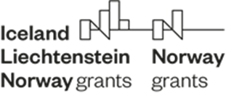
Annex 4

Approved by:
Director, Central Coordination Unit Directorate
and Head of NFP

.………………………………………………...
(Ivan Ivanov)
Date:
Version:

Fund for Bilateral Relations under the EEA FM and NFM 2014 – 2021
Travel Support Scheme
---------------------------------------------------------------------------------------------------------------------
Request for Reimbursement

Date of request:
Institution/Department/Division/

Field of activity (sector, area of interest):
Purpose of travel (describe the initiatives, date and place of travel):
Amount requested (EUR/BGN):
List of payment verification documents (attached in free form):
A complete set of payment verification documents, signed and stamped “Identical to the original”: (attached)
FINANCIAL IDENTIFICATION:
BANK NAME:
BRANCH ADDRESS:
IBAN:
BIC/SWIFT:

With this letter I declare that the information provided in the payment request and the attached documents is complete and accurate, and the costs incurred can be considered eligible in accordance with Chapter 8 of the Regulations on the implementation of the EEA FM and NFM 2014 – 2021 and the Agreement on the Fund for Bilateral Relations.

Official representative of the institution: /signature, stamp/

