
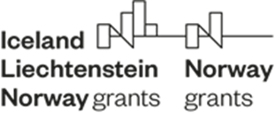
Annex 3

Approved by:
Director, Central Coordination Unit Directorate
and Head of NFP

.………………………………………………...
(Ivan Ivanov)
Date:
Version:

Fund for Bilateral Relations under the EEA FM and NFM 2014 – 2021
Travel Support Scheme
---------------------------------------------------------------------------------------------------------------------
Narrative Report

Institution/Department/Division/:
Purpose of the visit:
Description of the implemented activities (describe in details the initiatives, activities, participants, date and location):
Outcome of mission:
Attachments – training and other materials from the events

Official representative of the institution: /signature, stamp/

